**BUS TICKET RESERVATION**

**Modules:**

1. User management module
2. Bus management module
3. Booking/reservation module
4. Payment module

**The entities of the Bus Ticket Reservation are**

* User
* Bus
* Route
* Schedule
* Reservation
* Payment

**The attributes and relationships of each entity for Bus Management System**

**User:**

* UserID (Primary key)
* Username
* Password
* Email
* Role

**Relationship:**

* One user can maps to multiple reservations (One-to-Many).

**Bus:**

* BusID (Primary key)
* BusNumber
* Capacity
* Departure Location
* Arrival Location

**Relationship:**

* One bus can maps to multiple schedules (One-to-Many).

**Route:**

* RouteID (Primary key)
* Route name
* Departure Location
* Arrival Location
* Distance
* Duration

**Relationship:**

* One route maps to multiple schedules (One-to-Many).

**Schedule:**

* ScheduleID(Primary key)
* BusID(Foreign key)
* RouteID(Foreign key)
* Departure time
* Arrival time

**Relationship:**

* One schedule can have multiple reservations (One-to-Many).

**Reservation:**

* ReservationID (Primary key)
* UserID (Foreign key)
* ScheduleID (Foreign key)
* Reservation date
* Seat Number
* Status

**Relationship:**

* One reservation maps to one payment (One-to-One).

**Payment:**

* PaymentID (Primary key)
* ReservationID (Foreign key)
* Payment Amount
* Payment Date

**Relationship:**

* One reservation corresponds to one payment (One-to-One).

**ER DIAGRAM:**

One-to-Many

One-to-Many

One-to-many

One-to-One

ROUTE

PAYMENT

RESERVATION

One-to-Many

SCHEDULE

BUS

USER

**Creating Database:**

CREATE DATABASE BusTicketReservation;

USE BusTicketReservation;

**TABLE STRUCTURE:**

1. **User:**

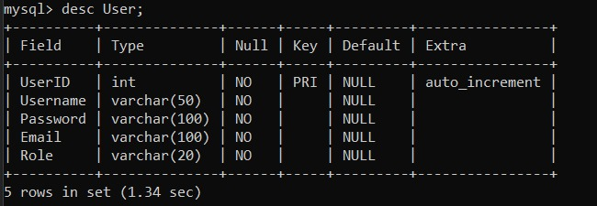

**2. Bus:**

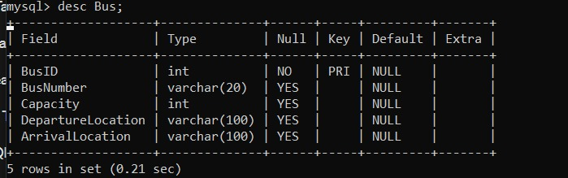

**3. Route:**

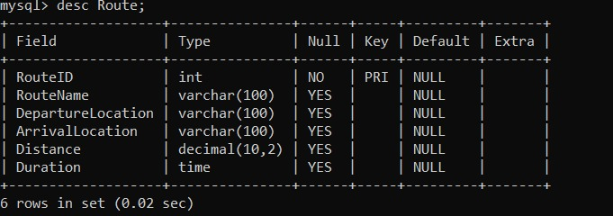

1. **Schedule:**

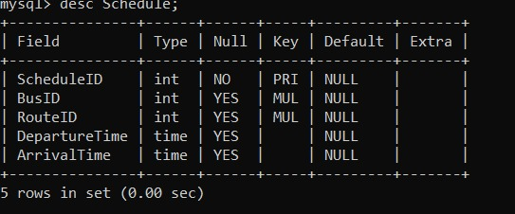

1. **Reservation:**

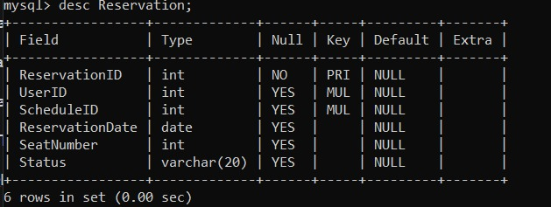

1. **Payment:**

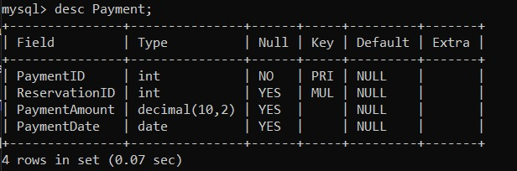

**Creating table for each entities:**

USE BusTicketReservation;

CREATE TABLE User (

UserID INT PRIMARY KEY AUTO_INCREMENT,

Username VARCHAR(255) NOT NULL,

Password VARCHAR(255) NOT NULL,

Email VARCHAR(255) NOT NULL,

Role ENUM('admin', 'regular') NOT NULL

);

CREATE TABLE Bus (

BusID INT PRIMARY KEY AUTO_INCREMENT,

BusNumber VARCHAR(255) NOT NULL,

Capacity INT NOT NULL,

DepartureLocation VARCHAR(255) NOT NULL,

ArrivalLocation VARCHAR(255) NOT NULL

);

CREATE TABLE Route (

RouteID INT PRIMARY KEY AUTO_INCREMENT,

RouteName VARCHAR(255) NOT NULL,

DepartureLocation VARCHAR(255) NOT NULL,

ArrivalLocation VARCHAR(255) NOT NULL,

Distance DECIMAL(10,2) NOT NULL,

Duration TIME NOT NULL

);

CREATE TABLE Schedule (

ScheduleID INT PRIMARY KEY AUTO_INCREMENT,

BusID INT,

RouteID INT,

DepartureTime DATETIME,

ArrivalTime DATETIME,

FOREIGN KEY (BusID) REFERENCES Bus(BusID),

FOREIGN KEY (RouteID) REFERENCES Route(RouteID)

);

CREATE TABLE Reservation (

ReservationID INT PRIMARY KEY AUTO_INCREMENT,

UserID INT,

ScheduleID INT,

ReservationDate DATE,

SeatNumber INT,

Status ENUM('reserved', 'cancelled') NOT NULL DEFAULT 'reserved',

FOREIGN KEY (UserID) REFERENCES User(UserID),

FOREIGN KEY (ScheduleID) REFERENCES Schedule(ScheduleID)

);

CREATE TABLE Payment (

PaymentID INT PRIMARY KEY AUTO_INCREMENT,

ReservationID INT,

PaymentAmount DECIMAL(10,2) NOT NULL,

PaymentDate DATE NOT NULL,

PaymentStatus ENUM('pending', 'completed', 'failed') NOT NULL DEFAULT 'pending',

FOREIGN KEY (ReservationID) REFERENCES Reservation(ReservationID)

);

**Insert records**

**--Insert User**

INSERT INTO User (Username, Password, Email, Role)

VALUES

('John_doe', 'password123', 'john.doe@example.com', 'admin'),

('Jane_smith', 'abc123', 'jane.smith@example.com', 'regular'),

('Alice_wong', 'pass456', 'alice.wong@example.com', 'regular'),

('Abinaya', 'abi123', 'abi@example.com', 'admin'),

('Krithika', 'krithi456', 'krithika@example.com', 'admin');

**--Insert Bus**

INSERT INTO Bus (BusNumber, Capacity, DepartureLocation, ArrivalLocation)

VALUES

('Bus001', 50, 'Nagercoil', 'Chennai'),

('Bus002', 40, 'Chennai', 'Madurai'),

('Bus003', 60, 'Madurai', 'Virudhunagar');

**--Insert Route**

INSERT INTO Route (RouteName, DepartureLocation, ArrivalLocation, Distance, Duration)

VALUES

('Route1', 'Nagercoil', 'Chennai', 100.00, '02:30:00'),

('Route2', 'Chennai', 'Madurai', 150.00, '03:00:00'),

('Route3', 'Madurai', 'Virudhunagar', 120.00, '02:45:00');

**--Insert Schedule**

INSERT INTO Schedule (BusID, RouteID, DepartureTime, ArrivalTime)

VALUES

(1, 1, '2024-03-01 08:00:00', '2024-03-01 10:30:00'),

(2, 2, '2024-03-02 09:00:00', '2024-03-02 12:00:00'),

(3, 3, '2024-03-03 10:00:00', '2024-03-03 12:45:00');

**--Insert Reservation**

INSERT INTO Reservation (UserID, ScheduleID, ReservationDate, SeatNumber, Status)

VALUES

(1, 1, '2024-03-01', 1, 'reserved'),

(2, 2, '2024-03-02', 5, 'reserved'),

(3, 3, '2024-03-03', 10, 'reserved');

**--Insert Payment**

INSERT INTO Payment (ReservationID, PaymentAmount, PaymentDate, PaymentStatus)

VALUES

(1, 50.00, '2024-03-01', 'completed'),

(2, 40.00, '2024-03-02', 'completed'),

(3, 60.00, '2024-03-03', 'completed');

**Select records**

**Retrieve all User:**

Select * FROM User;

**Retrieving the information we needed:**

Select Email from User where Username=’Abinaya’;

Select PaymentAmount from Payment where PaymentDate='2024-03-02';

Select ScheduleID from Reservation where SeatNumber=5;

**Update Records**

Update User SET email = 'johndoe@example.com' Where Username = 'John_doe';

Update Bus SET Capacity= '44' Where BusNumber = ' Bus003';

Update Route SET Distance= '1200' Where RouteName = 'Route1';

**Delete records**

Delete FROM User where Password=' pass456';